**EXPERIMENT NUMBER –2.5**

**Student Name: Shinde Smita Shahaji UID: 20BCS4643**

**Branch: CSE (IOT) Section/Group: IOT (Group-B)**

**Semester: 2nd semester Date of Performance:02/04/2021**

**Subject Name: Quantum and Semiconductor physics lab**

AIM OF THE EXPERIMENT –

To determine the diffraction using laser beam and find the grating element of diffraction grating.

APPARATUS-

|  |  |  |  |
| --- | --- | --- | --- |
| Sr.NO | Equipment | Range | Quantity |
| 1. | Power Supply/Operating Voltage | 5mV/3-12V | 1 |
| 2. | Laser | 400-700nm | 1 |
| 3. | Grating element | 250-500 liters per mm | 1 |
| 4. | Stand | NA | 2 |

* **Introduction/Theory:**

**Diffraction** is the slight bending of light as it passes around the edge of an object. The amount of bending depends on the relative size of the wavelength of light to the size of the opening.

**Diffraction grating:** It is a set of thousands of narrow, closely spaced parallel slits; typically the distance between the lines is comparable to the wavelength of light. Distance between two consecutive slits (lines) of a

grating is called grating element (d)**.** Light rays that pass through such a surface are bent as a result of diffraction, related to wave properties of light. The diffraction angle depends upon the wavelength of the light, for a given Grating light with larger wavelength has larger diffraction angle. More precisely a single wavelength can simultaneously have multiple discrete diffraction

6 angles called diffraction orders.

For normal illumination, the grating equation is given by

(a+b) sin θ =n λ

d sin θ = n λ (1)

Where θ is the angle of diffraction, (a+b) is the grating element n =0, ±1,

±2….and λ is the wavelength of light used.

Diagram-

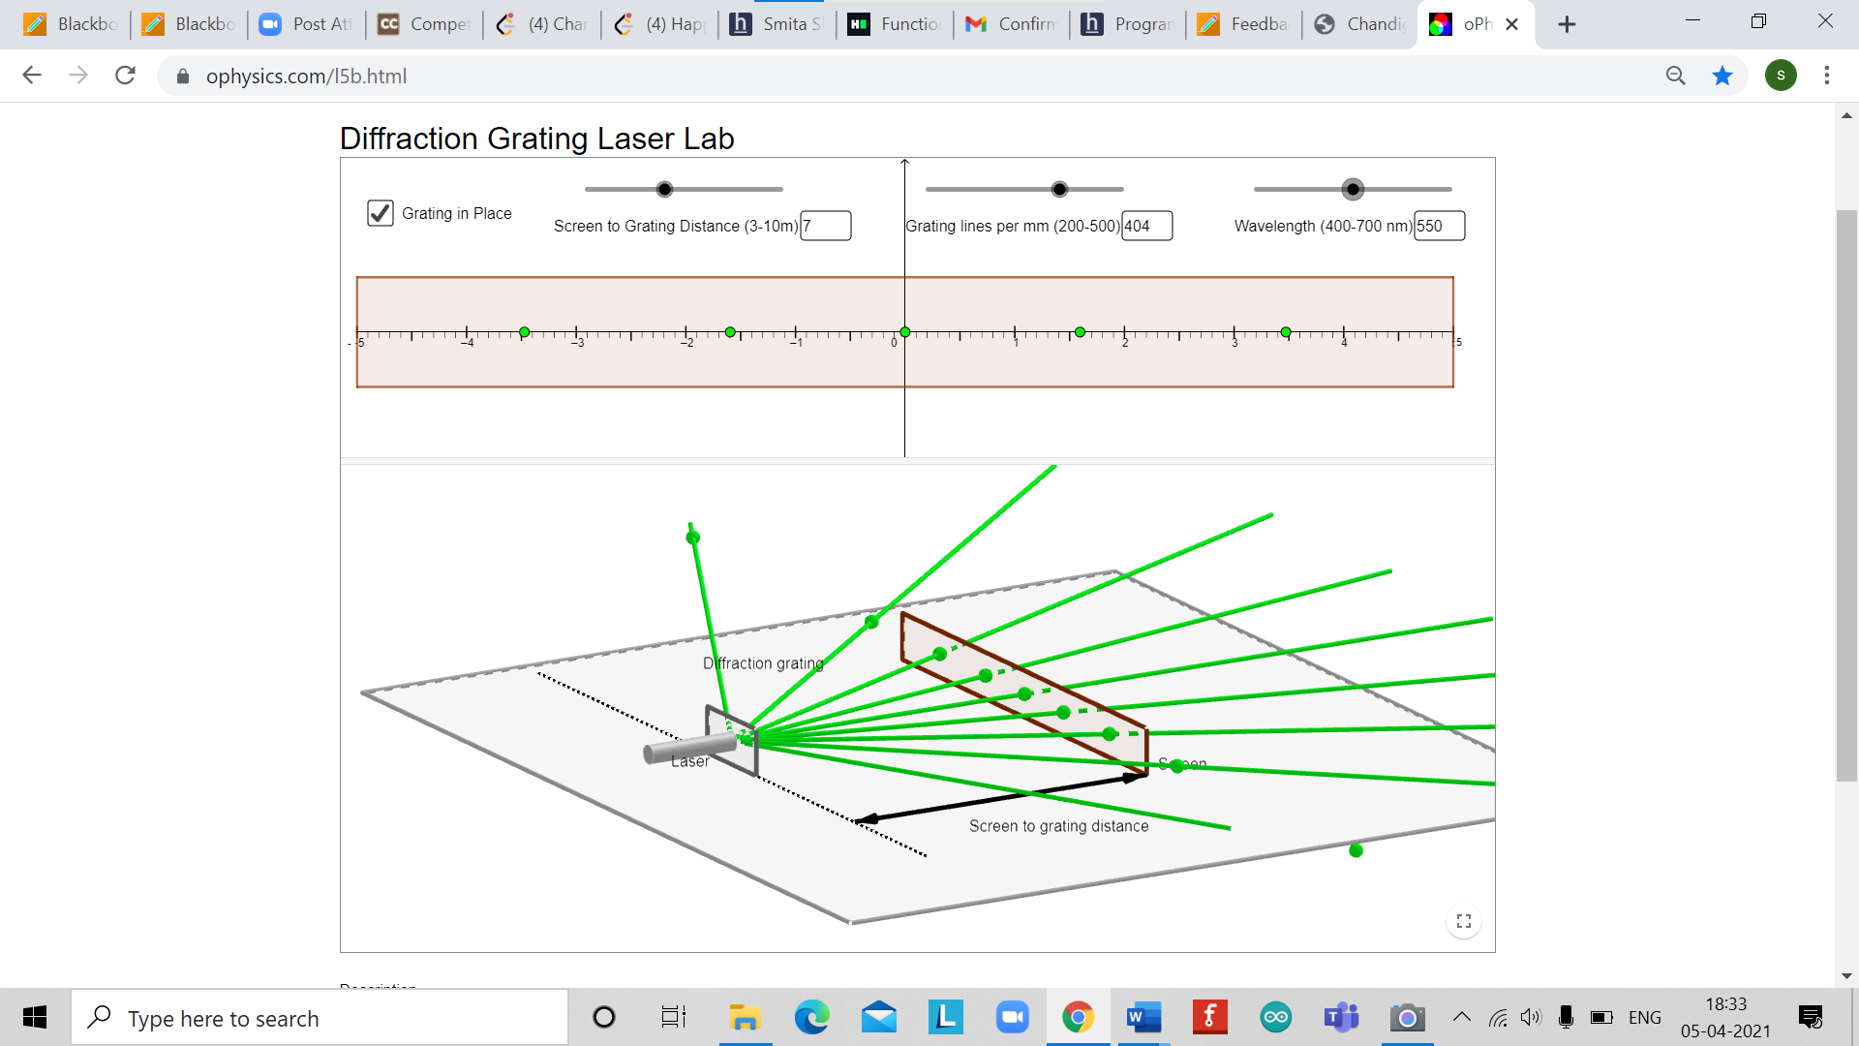

OBSERVATIONS-

|  |  |  |  |  |  |  |  |
| --- | --- | --- | --- | --- | --- | --- | --- |
| S. No. | Order of diffraction(n) | Position of nth order maxima | | Mean distance Of nth Order maxima from zeroth order (cm) | Distance Between Grating and screen (D)(m | sin θ = OPn    √opn2 +D2 | d=nλ  Sin θ  (cm) |
| On 1 left (OPn)  cm | On Right (OPn’)cm |
| 1. | N=1 | OP1 = 1.6 | OP1’=1.6 | 1.6 | 7 | 0.03 | d1=0.0182 *  10^-4m |
| 2. | N=2 | OP2= 3.45 | OP2’=  3.45 | 3.45 | 7 | 0.05 | d2= 0.218*10^-4m |

CALCULATIONS-

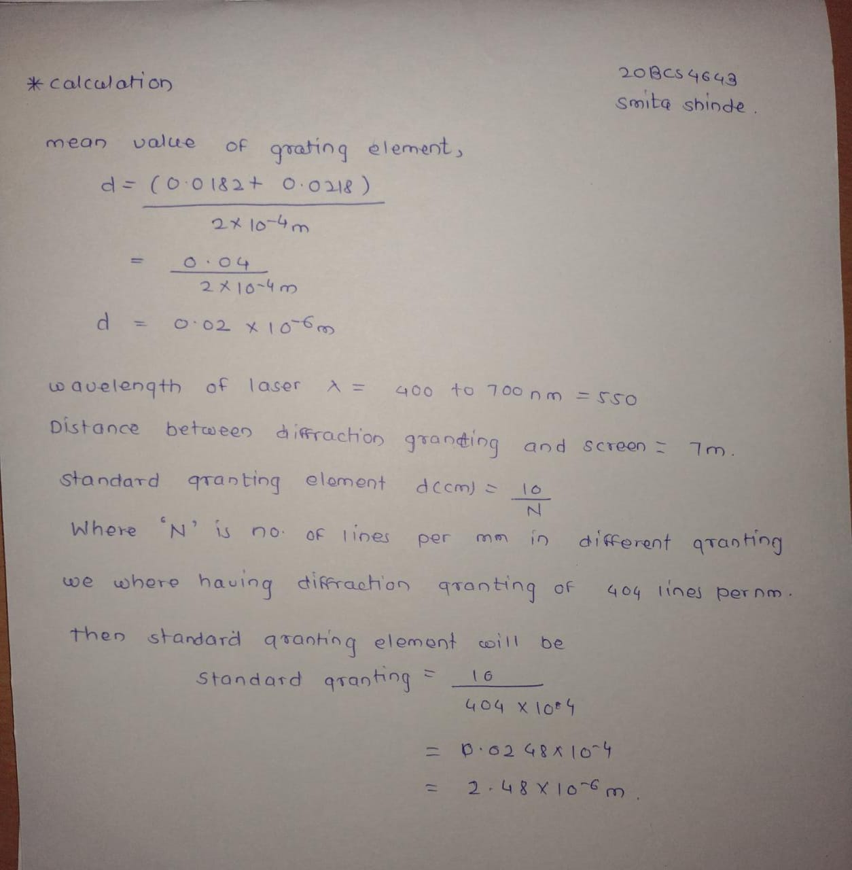

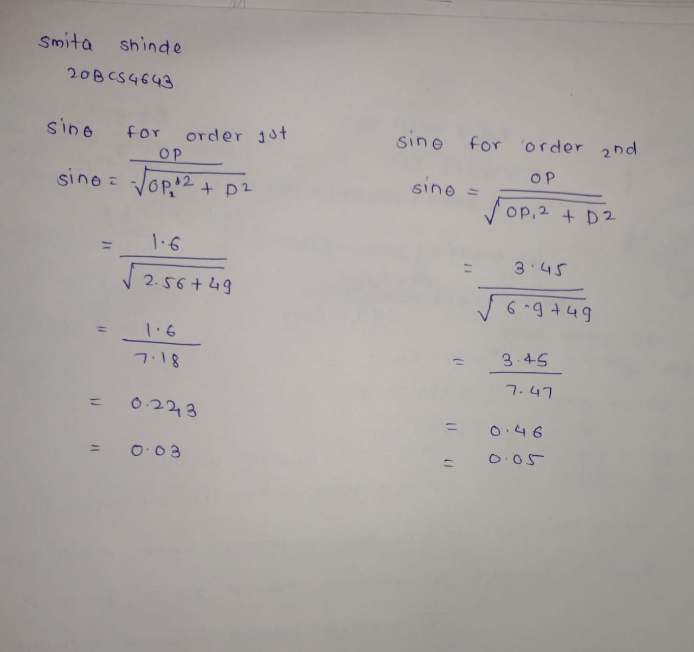

PERCENTAGE ERROR-

Standard value –observed value * 100%

Standard value

(|0.0248- 0.02|)/ 0.025 * 100%

= (0.00484 / 0.025) *100%

= 1.94%

GRAPH (ATTACH IF ANY)-

No graph

SOURCES OF ERROR-

1. The main source of error are the distance between the laser and the wall, and the size of dots. There is a further enlargement of dots due to attenuation as it passes through the air. This experiment would have been more accurate if executed in vacuum.
2. The dots on the extreme edges are also larger than they needed to be since the light is spread out and it is hitting the surface (the walls) at an angle.

RESULTS AND DISCUSSION-

1. Grating element d = 2 *10-6 m
2. Standard grating element d= 1/N

= 2.48 * 10-6 m

1. % age error = 1.94 %

LEARNING OUTCOMES

|  |
| --- |
| * It will provide the modest experience that allows students to develop and improve their experimental skills and develop ability to analyze data. |
| * Ability to demonstrate the practical skill on measurements and instrumentation techniques of some Physics experiments. Students will develop the ability to use appropriate physical concepts to obtain quantitative solutions to problems in physics. |
| * Students will demonstrate basic experimental skills by setting up laboratory equipment safely and efficiently, plan and carry out experimental procedures, and report verbally and in written language the results of the experiment. |
| * Students will develop skills by the practice of setting up and conducting an experiment with due regards to minimizing   measurement error. |

EVALUATION COLUMN (To be filled by concerned faculty only)

|  |  |  |  |
| --- | --- | --- | --- |
| **Sr. No.** | **Parameters** | **Maximum Marks** | **Marks Obtained** |
| 1. | Worksheet completion including writing learning objectives/Outcomes. (To be submitted at the end of the day) | 10 |  |
| 2. | Post Lab Quiz Result. | 5 |  |
| 3. | Student Engagement in Simulation/Demonstration/Performance and Controls/Pre-Lab Questions. | 5 |  |
| 4. | Total Marks | 20 |  |
| 5. | Teacher’s Signature (with date) |  | |